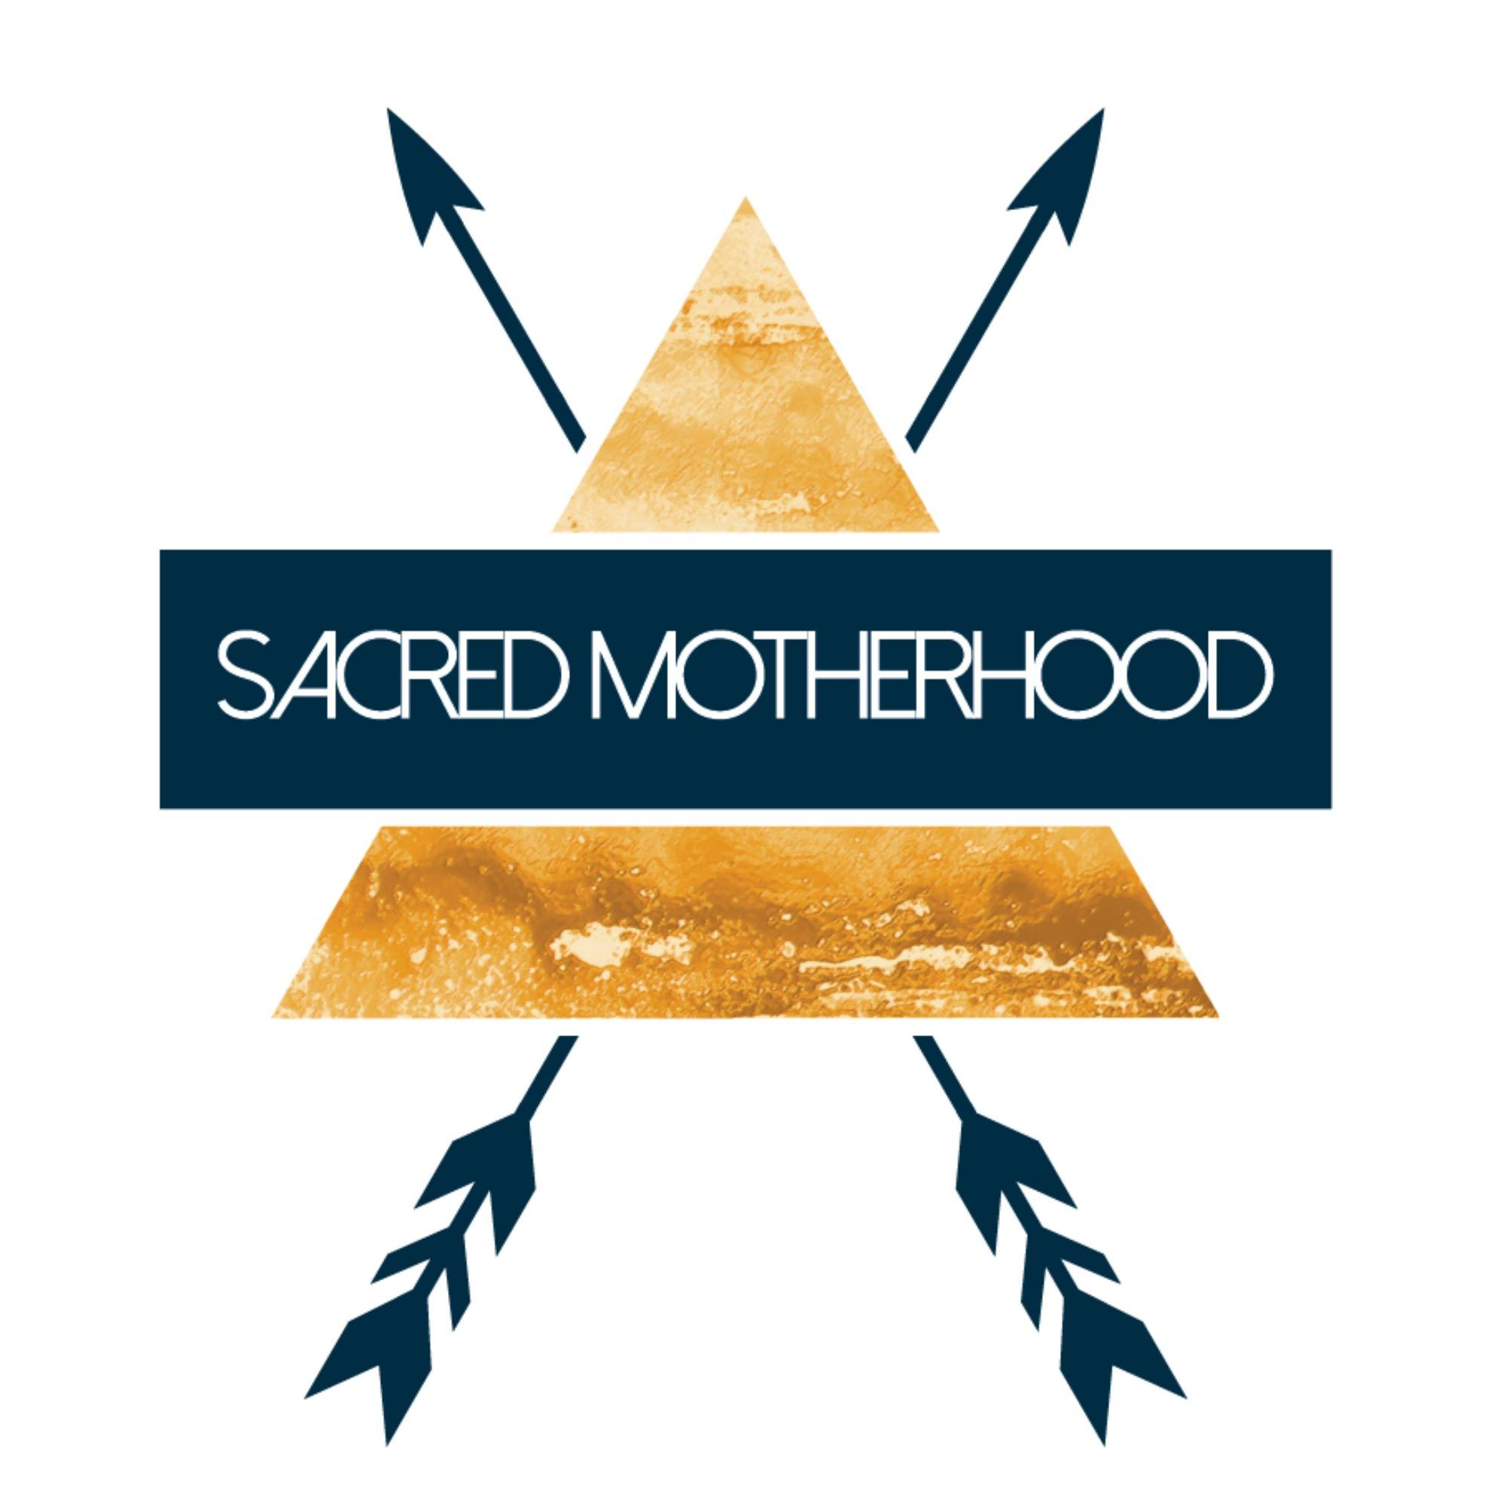

Sacred Motherhood Circle
Tending the Soul Fire
Our Sacred Motherhood Circle is for women only (no kids), and this circle is for mamas of children ages Birth to 5 years. We will meet once per month. The Circle is arranged for three classes in each season, and is held at the Shanti Center, 700 Dupont St, Bham

Name: Email:

Address: Phone:

Who referred you to the Sacred Motherhood Circle?

Have you read Sacred Motherhood by Anni Daulter & Niki Dewart?

Children’s Names and Ages:

Class Tuition:
Demo Class (May 20, 2017): $25
Single Class: $60
Season (3 Circles in 3 months): $165 ($55/Circle)
Annual (1 Circle each month for a year): $600 ($50/Circle)

A non-refundable deposit of $40 will hold your place in the Circle.
To pay the remaining fee, please choose one of the following options:
_____ I will pay the full amount, due on the first Circle (best price)
_____ I will pay in Seasonal Installments, due at the beginning of each season
(January, April, July, October)
_____ Please send billing via Paypal to: ________________________

All payments and registration materials can be sent to
Mary Burgess: 3039 Peabody St, Bellingham, WA 98225

Thank you for answering the following questions. It is an opportunity to think about what you are hoping to receive from your Sacred Motherhood Circle and what you are bringing with you as offering:

- What inspires you most about motherhood?

- What called you to the Sacred Motherhood Circle?

- What aspect of mothering do you find most challenging?

- When you hear the word Sisterhood, what does that mean to you?

- What aspect of your self shines brightest? What are your greatest strengths? (We really want to know!)

- What do you hope to receive from this Circle?

Thank you for your beautiful honesty! We look forward to meeting you and having you in the Sacred Motherhood Circle.

